Bangladesh Medical Association (BMA)
List of Life Member-41
27. BMA Joypurhat Branch

Sl No | Voter No | Voter Details
1 | Voter No  LM-2700001  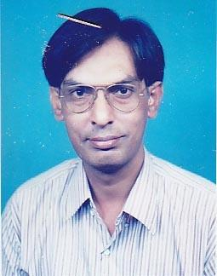 | DR. MD. REZAUL ALAM  F/Name: Md. Abul Hossain Sarder  M/Name:  BM & DC Reg. No:  NID:  Cell:  Address: Sadar Hospital, Jaipurhat, Joypurhat  Blood Group:
2 | Voter No  LM-2700002  No Image | DR. RATHINDRA NATH KUNDU  F/Name: Late Rabindra Nath Kundu  M/Name:  BM & DC Reg. No:  NID:  Cell:  Address: Medical Officer, Jail Hospital Joypurhat  Blood Group:
3 | Voter No  LM-2700003 | DR. MD. DABIR UDDIN SARDAR  F/Name:  M/Name:  BM & DC Reg. No:  NID:  Cell:  Address: TH & FPO.,Joypurhat  Blood Group:
4 | Voter No  LM-2700004  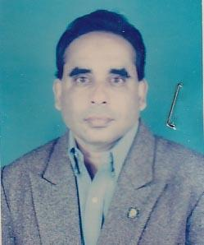 | DR. K.M. SAIFUL ISLAM DAVID  F/Name: Late Kazi Solaiman Ali  M/Name:  BM & DC Reg. No:  NID:  Cell:  Address: Vill. Debipur , Post. Joypurhat Joypurhat  Blood Group:  E X P I R E D
5 | Voter No  LM-2700005 | DR. MD. SHAHID HOSSAIN  F/Name: Md. Sagir Hossain  M/Name:  BM & DC Reg. No:  NID:  Cell:  Address: Madrasha Para, Shadman Clinic Joypurhat  Blood Group:
6 | Voter No  LM-2700006  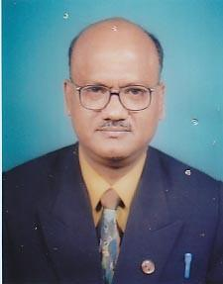 | DR. MD. MAMOTAZ HOSSAIN  F/Name: Late Osiruddin  M/Name:  BM & DC Reg. No:  NID:  Cell:  Address: 65, New Eskaton Road, Bangla Motor Dhaka  Blood Group:
7 | Voter No  LM-2700007  No Image | DR. MD. MOFIZUL ISLAM TALUKDER  F/Name:  M/Name:  BM & DC Reg. No:  NID:  Cell:  Address:  Blood Group:  TRANSFERED to BMA Dhaka City  LM-1405543
8 | Voter No  LM-2700008 | DR. MD. SABA AL GALIB  F/Name: Md. Aowfar Hossain  M/Name: Mst. Suraiya Khatun  BM & DC Reg. No: 62577  NID: 6125217227413  Cell: 01710327687  Address: Vill+Post-Bagzana, Pancbibi, Joypurhat  Blood Group: O+
9 | Voter No  LM-2700009  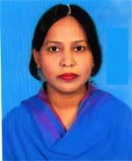 | DR. MORSHED FARHANA PARVIN  F/Name: Md. Moslem Uddin  M/Name: Mrs. Jahanara Begum  BM & DC Reg. No: 30854  NID: 2690243819044  Cell: 01718695484  Address: Physician Specialist, Marie Stopes Materinity C.O Colony, Sadar Road, Joypurhat  Blood Group: B+
10 | Voter No  LM-2700010 | DR. MOHAMMAD ATIQUR RAHMAN  F/Name: Eng Hafizur Rahman  M/Name: Afroza Begum  BM & DC Reg. No: 32419  NID: 3824706131101  Cell: 01711931002  Address: MO, District Hospital, Joypurhat  Blood Group: B+
11 | Voter No  LM-2700011 | DR. A. S. M. GOLAM RABBANI  F/Name: Md. Nazar Ali Mondal  M/Name: Rashida Begum  BM & DC Reg. No: 23553  NID: 2695435083343  Cell: 01815488454  Address: Banga Bandhu road, Joypurhat Sadar  Blood Group: B+
12 | Voter No  LM-2700012  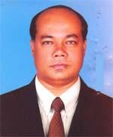 | DR. MD. ZAFAR IMAM  F/Name: Late Tasir Uddin Munshi  M/Name: Late Rabeya Begum  BM & DC Reg. No: 25445  NID: 3824706126655  Cell: 01712015630  Address: District Hospital, Joypurhat  Blood Group: B+
13 | Voter No  LM-2700013 | DR. MD. MAHBUBUL HAQUE  F/Name: Md. Shamsul Haque  M/Name: Dolly Haque  BM & DC Reg. No: 50912  NID: 19858198510364634  Cell: 01712652116  Address: Arafat Nagor, Sadar, Joypurhat, (C.O. Collony)  Blood Group: A+
14 | Voter No  LM-2700014  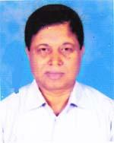 | DR. MD. MOZAMMEL HAQUE  F/Name: Md. Mofiz Uddin Molla  M/Name: Mst. Jebunnessa  BM & DC Reg. No: 13630  NID: 6920908693109  Cell: 01712501800  Address: Vill-Damdama (Hili road) Post-panchbibi, Upazila-Panchbibi, Dist-Joypurhat  Blood Group: AB+
15 | Voter No  LM-2700015  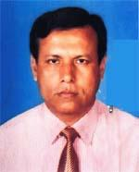 | DR. MD. KHURSHID ALAM  F/Name: Late Dr. Talebur Rahman  M/Name: Late Anwara Begum  BM & DC Reg. No: 19449  NID: 3824706131438  Cell: 01712290914  Address: Superintendent Modernized Dist Hospital , Joypurhat  Blood Group: O+
16 | Voter No  LM-2700016  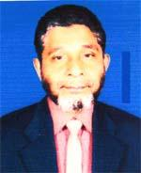 | DR. DEWAN MD. AMINUL ISLAM  F/Name: Late Ehia Ali Dewan  M/Name: Fatema Khanum  BM & DC Reg. No: 14511  NID: 3824705121513  Cell: 01711383175  Address: Dewan Monjil , Jamalganj Road, Post+Dist-Joypurhat  Blood Group: B+
17 | Voter No  LM-2700017  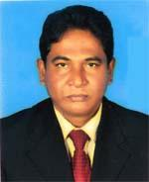 | DR. MD. MAFIUR RAHMAN  F/Name: Late Md. Nurul Islam Mondal  M/Name: Jamila Beoya  BM & DC Reg. No: 22334  NID: 2690243819045  Cell: 01728237077  Address: Senior Consultant(Surgery), Modernized, Dist Hospital, Joypurhat  Blood Group: A+
18 | Voter No  LM-2700018  No Image | ***NIL***  F/Name:  M/Name:  BM & DC Reg. No:  NID:  Cell:  Address:  Blood Group:
19 | Voter No  LM-2700019 | DR. RADHE SHUYAM AGARWALA  F/Name: Late Satya Narayon Agarwala  M/Name: Parboti Devi  BM & DC Reg. No: 25529  NID: 19643824709145750  Cell: 01712073668  Address: Doctors Quarter, Upazilla Health Complex, Aklalpur, Joypurhat  Blood Group: A+
20 | Voter No  LM-2700020  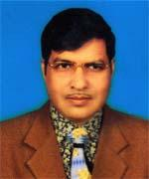 | DR. MD. MONIRUZZAMAN MOLLAH  F/Name: Late Abul Kashem Mollah  M/Name: Mst. Mahmuda Khanom  BM & DC Reg. No: 24216  NID: 3827403493235  Cell: 01712015132  Address: Village-Balighata Bazar, Post+Upazilla-Panchbibi, Dist-Joypurhat  Blood Group: O+
21 | Voter No  LM-2700021  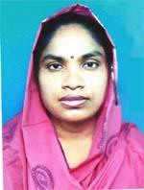 | DR. MORSHEDA KHATUN  F/Name: Mohammad Taj Uddin  M/Name: Mst. Hasna Begum  BM & DC Reg. No: 43786  NID: 1022010402003  Cell: 01718443437  Address: Santi Nagor, College Road, Joypurhat  Blood Group: O+
22 | Voter No  LM-2700022 | DR. MOWPIYA MONDAL  F/Name: Nirmal Kumar Mondal  M/Name: Mina Rani Mondal  BM & DC Reg. No: 63633  NID: 19883824701000021  Cell: 01710549342  Address: Sugar Mills Road, Master Para, Joypurhat  Blood Group: B+
23 | Voter No  LM-2700023  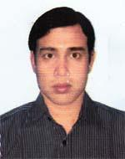 | DR. M. N. A. AL MEHDI  F/Name: Tazim Uddin Ahmed  M/Name: Mst. Salma Begum  BM & DC Reg. No: 39041  NID: 3811331385345  Cell: 01711365017  Address: Vill-Debisaul, Post-Raikali, Thana-Akkelpur, Dist-Joypurhat  Blood Group: O+
24 | Voter No  LM-2700024 | DR. MD. SHAHNAWAS BISWAS  F/Name: Mannan Biswas  M/Name: Shahanara Begum  BM & DC Reg. No: 66694  NID: 2691647024561  Cell: 01754380564  Address: House No. 14612, Road No. 9/A, West Dhanmondi, Dhaka-1209  Blood Group: B+
25 | Voter No  LM-2700025  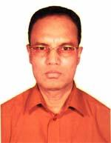 | DR. MD. ABU HOSSAIN MONDAL  F/Name: Late Umir Uddin Mondal  M/Name: Late Morium Begum  BM & DC Reg. No: 16409  NID: 3825801394592  Cell: 01715649598  Address: UHC, Kalai, Joypurhat  Blood Group: O+
26 | Voter No  LM-2700026  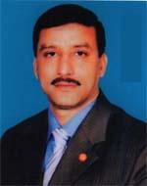 | DR. HABIBUL AHSAN TALUKDER  F/Name: Late Tofazzal Hossain Talukder  M/Name: Hosne Ara Begum  BM & DC Reg. No: 17900  NID: 3824708137222  Cell: 01725014556  Address: Upazilla Health Complex, Kalai, Joypurhat  Blood Group: B+
27 | Voter No  LM-2700027  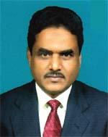 | DR. AKM. MUAZZEM HOSSAIN  F/Name: Late Abdul Momin Mondal  M/Name: Late Romicha Khatun  BM & DC Reg. No: 6183  NID:  Cell: 01768957946  Address: Nahan Villa, Post oftice Road, Panchbibi, Joypurhat  Blood Group: O+
28 | Voter No  LM-2700028 | DR. JAKIA AKHTER  F/Name: Md. Abdul Jabbar  M/Name: Mofiza Akhter  BM & DC Reg. No: 21013  NID: 19673824706000002  Cell: 01916509540  Address: G 9, Housing Estate, Joypurhat.  Blood Group:
29 | Voter No  LM-2700029 | DR. MD. NAZRUL ISLAM  F/Name: Late Dr. Lutfor Rahman  M/Name: Late Rashida Khatun  BM & DC Reg. No: 21587  NID:  Cell: 01711976772  Address: Doctors Clinic, Joypurhat  Blood Group: O+
30 | Voter No  LM-2700030 | DR. JOHN THEOTONIUS COSTA  F/Name: Late Michael Costa  M/Name: Late Mrs. Maria Doly Costa  BM & DC Reg. No: 18307  NID: 3824702107220  Cell: 01713248445  Address: Khanjarpur Mission Health Service JPHT, Joypurhat-5900.  Blood Group: A+
31 | Voter No  LM-2700031  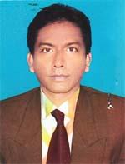 | DR. KAZI KHALID RAIHAN  F/Name: Late Kazi Tazul Islam  M/Name: Mrs. Anarkoli Islam  BM & DC Reg. No: 26059  NID: 3824706128918  Cell: 01712194196  Address: Madrasha Para, Joypurhat  Blood Group: O+
32 | Voter No  LM-2700032  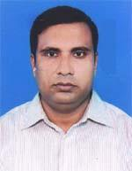 | DR. SARDAR MD. RAFIQUL MOBAROK  F/Name: Sardar Mobarok Ali  M/Name: Mrs. Rawshan Ara  BM & DC Reg. No: 27956  NID: 3824706130097  Cell: 01711129750  Address: Sardar Para (Natunhat), Joypurhat  Blood Group: O+
33 | Voter No  LM-2700033  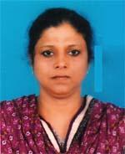 | DR. NAHID SULTANA  F/Name: Mir Md. Kamruzzaman  M/Name: Late Safura Khatun  BM & DC Reg. No: 23596  NID: 8192219329024  Cell: 01712247464  Address: Mordanized District Hospital, Joypurhat  Blood Group: O+
34 | Voter No  LM-2700034 | DR.MD. MOSHIUR RAHMAN  F/Name: Late Md. Lutfur Rahman  M/Name: Late Rashida Khanom  BM & DC Reg. No: 31700  NID: 3824709145635  Cell: 01711193328  Address: New Doctors Clinic, Sonar Patty, Joypurhat  Blood Group: O+
35 | Voter No  LM-2700035  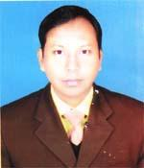 | DR. KM ZOBAIER GALIB  F/Name: Late Kazi Tazul Islam  M/Name: Mrs. Anarkwli  BM & DC Reg. No: 23331  NID: 3824708137340  Cell: 01712141165  Address: Professor Para, Bodor Uddin Road, Joypurhat  Blood Group: O+
36 | Voter No  LM-2700036  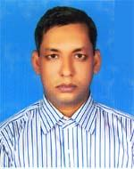 | DR. MD. ANOWAR HOSSAIN  F/Name: Md. Shahjahan Ali  M/Name: Most. Bilkis Begum  BM & DC Reg. No: 36727  NID: 3824706130635  Cell: 01711071324  Address: Shabuj Nagar Joypurhat  Blood Group: B+
37 | Voter No  LM-2700037  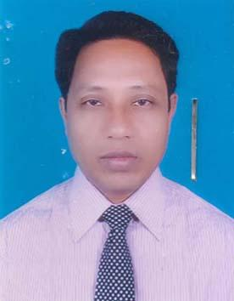 | DR. TULSHI CHANDRA ROY  F/Name: Rajendro Nath Roy  M/Name: Late Niroda Rani Roy  BM & DC Reg. No: 23103  NID: 6926305366362  Cell: 01741388018  Address: Medical Officer Adhunik Sadar Hospita, Jaypurhat.  Blood Group: B+
38 | Voter No  LM-2700038  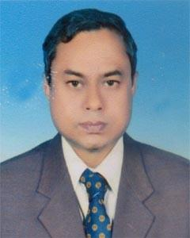 | DR. BIPUL CHANDRA MONDAL  F/Name: Brazalal Mondal  M/Name: Lilaboti Mondal  BM & DC Reg. No: 18908  NID: 3824702109407  Cell: 01712-204664  Address: Vill & Post Khanjanpur, Joypurhat.  Blood Group: A+
39 | Voter No  LM-2700039  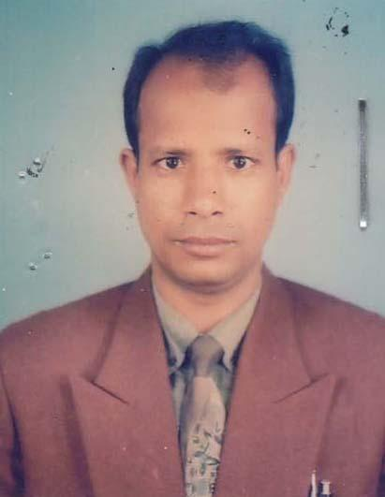 | DR. NUR MOHAMMAD SHEIKH  F/Name: Late Akbar Ali Sheikh  M/Name: Mst. Kohinur Begum  BM & DC Reg. No: 21467  NID: 3824706127922  Cell: 01712772004  Address: Diabetic Hospital Joypurhat.  Blood Group: A+
40 | Voter No  LM-2700040  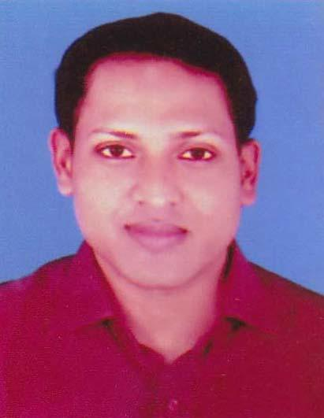 | DR. AMIT KUMAR MORE  F/Name: Gopal Prashad More  M/Name: Swapna More  BM & DC Reg. No: 77267  NID: 19913824708000031  Cell: 01715198531  Address: Purbo Bazar, Mosjid Road, Joypurhat.  Blood Group: A+
41 | Voter No  LM-2700041  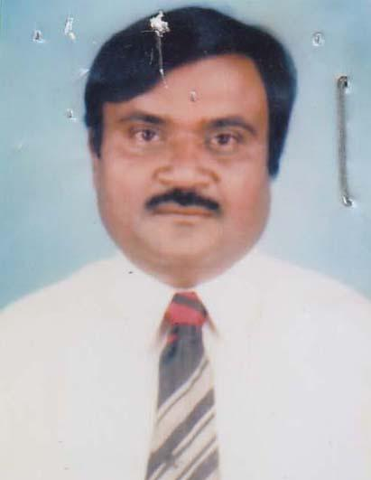 | DR. MD. RAFIQUL ISLAM  F/Name: Md. Foyezuddin Ahmed  M/Name: Mazeda Khatun  BM & DC Reg. No: 10577  NID: 3824709143394  Cell: 01717757054  Address: Purbo bazar, Bandan Clinic, Joypurhat.  Blood Group:

